Food For Friends Web Application Test Plan

Group Two

James Boehm, Marcus Jones, David Markowski

Ray Gutierrez, Andrew Delgado, David Batdorf

November 10, 2019

CMSC 495

Professor Terrence Mentzos

Food For Friends Web Application Test Plan

As we looked to have a flawless product launch, it was evident that a well-planned test plan was pivotal to introduce our Food for Friends web application. To develop a solid functioning application, we executed a test plan using an Agile Model. Ambler stated the key to software development success is keep all project stakeholders engaged in two-way communication to strive to develop the simplest solution possible that meets all of your needs (2018). We at the KISS group, have coupled a product test plan to compliment the project plan. A simple test plan lays a road map for how we will test the Food For Friends successfully validates requirements criteria.

Two principle tenets and a few precepts where established to validate under this test plan as users navigate application. First principle tenet, the application should be tailored to create an avenue for an individual or group (Giver) with any excess food a central location to post the availability of their free food. Next principle tenet, the submitted food will be posted in a map-like environment, upon which personnel (Recipient) can navigate based on either availability, gastronomic preference, or location. Additionally, since the principle tenets were the keystones of the application, two precepts to include application security, and application integrity will be required to ensure the application is vested. Finally, the Giver and/or Recipient application flow path should be user friendly. Please refer to Figure 1 below of simplified flow path.

Test Usage Criteria:

* High Level Cumulative Interaction

1. Kate (Giver) signs into the web application “Food For Friends”

2. Kate (Giver) selected Giver Mode

3. Kate (Giver) Selects Post Food Item

4. Kate (Giver) Enters the following information

a. Food Description: Meat Free Chili

b. Number of Servings Available: 5 (from drop down menu)

c. Food availability window: 3 hours (from drop down menu)

d. Radius of availability: 10 miles (from drop down menu)

5. Kate (Giver) clicks the post button

6. John (Recipient) signs into the application

7. John selects Receiver Mode

8. John (Recipient) sees Kate (Giver) nearby post as he is located 2 miles away.

9. John (Recipient) selects Kate (Giver) post via a pin on his local map.

10. John (Recipient) receives the location of Kate (Giver) offering and is able to input the location into a mapping application of his choice

11. Internally the application links John (Recipient) and Kate (Giver), allowing them to rate the interaction.

* Giver Interaction
  + Expected Scenario

1. Kate (Giver) signs into the web application “Food For Friends”

2. Kate (Giver) selected Giver Mode

3. Kate (Giver) Selects Post Food Item

4. Kate (Giver) Enters the following information

a. Food Description: Meat Free Chili

b. Number of Servings Available: 5 (from drop down menu)

c. Food availability window: 3 hours (from drop down menu)

d. Radius of availability: 10 miles (from drop down menu)

5. Kate (Giver) clicks the post button

6. Kate (Giver) and John (Recipient) transaction ensues.

7. Kate (Giver) rates the interaction.

* + Unexpected Scenario

1. Kate (Giver) signs into the web application “Food For Friends”

2. Kate (Giver) selected Giver Mode

3. Kate (Giver) Selects Post Food Item

4. Kate (Giver) Enters the following offensive information

a. Food Description: Meat @#$%^& Chili

1. Application find dirty word in food label

2. Application prompts Giver to correct offensive word.

5. Kate (Giver) continues expected path scenario.

* Recipient Interaction Scenario
  + Expected Scenario

1. John (Recipient) signs into the application

2. John (Recipient) selects Receiver Mode

3. John (Recipient) searches the following information on map as

indicated by icon. Selecting icon (pin) displays:

a. Food Description: Meat Free Chili

b. Number of Servings Available: 5

c. Food availability window: 3 hours (Based on countdown clock)

d. Radius of availability: 10 miles

4. John (Recipient) finds and selects Kate (Giver) post via a pin on his local map.

5. John (Recipient) receives the location of Kate (Giver) offering and is able to input the location into a mapping application of his choice

6. John (Recipient) is able to rate the interaction after.

* + Unexpected Scenario

1. John (Recipient) signs into the application

2. John (Recipient) selects Receiver Mode

3. John (Recipient) searches the following information on map as

indicated by icon. Selecting icon (pin) displays:

a. Food Description: Meat Free Chili

b. Number of Servings Available: 5

c. Food availability window: 3 hours (Based on countdown clock)

d. Radius of availability: 10 miles

4. John (Recipient) search results in no selection criteria met on local map.

a. Message displayed of null search results.

b. Message also allows Recipient the choice:

1. Exiting application

2. Restarting search by prompting new search entry or freestyle map view for further selection based on availability.

5. John (Recipient) now looped into expected scenario condition.

* Application Security Scenario
  + Expected Scenario

1. New user navigates to web application.
2. Upon entry, selects New Account link.
3. Enters:
   1. First Name
   2. Last Name
   3. Address
   4. Phone
   5. Select Giver and/or Recipient category
   6. Select authentication methodology, as applicable. Successful!
4. User now signs in and follows Giver/Recipient expected scenario modeled above.
   * Unexpected Scenario

1. New user navigates to web application.

2. Upon entry, selects New Account link.

3. Enters:

a. First Name

b. Last Name

c. Address

d. Phone

e. Select Giver and/or Recipient category

f. Select authentication methodology, as applicable. Authentication failed.

1. Error message displayed.

2. Perform error mitigation, as required.

4. User now signs in

* Application Integrity Scenario
  + Expected Scenario

1. Kate (Giver) signs into the web application “Food For Friends”

2. Kate (Giver) selected Giver Mode

3. Kate (Giver) Selects Post Food Item

4. Kate (Giver) Enters the following information

a. Food Description: Meat Free Chili (Only food items allowed)

b. Number of Servings Available: 5 (from drop down menu)

c. Food availability window: 3 hours (from drop down menu)

d. Radius of availability: 10 miles (from drop down menu)

5. Kate (Giver) clicks the post button

6. Kate (Giver) and John (Recipient) transaction ensues.

7. Kate (Giver) rates the interaction.

* + Unexpected Scenario

1. Kate (Giver) signs into the web application “Food For Friends”

2. Kate (Giver) selected Giver Mode

3. Kate (Giver) Selects Post Food Item

4. Kate (Giver) Enters the following non-food item (i.e. old sofa)

a. Food Description: Gently used sofa

1. Application find non-food item in food label

2. Application prompts Giver to correct non-food item.

5. Kate (Giver) continues expected path scenario.

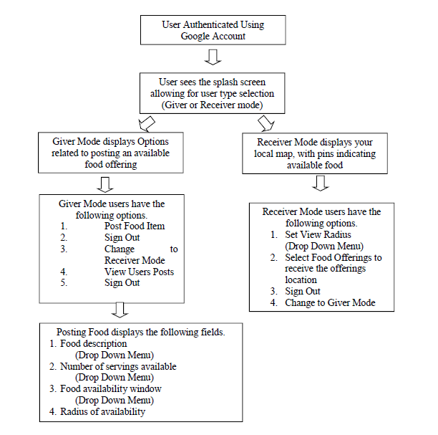

Figure 1. Giver or Recipient Flow Path

References:

Ambler, S. W. (2018). An Introduction to Agile Modeling. Retrieved from

http://www.agilemodeling.com/essays/introductionToAM.htm.